Still soft and stretchy
Dinosaur soft tissue find—a stunning rebuttal of “millions of years”
by Dr Carl Wieland, AiG–Australia
25 March 2005
We previously announced the discovery of what seemed to be microscopic red blood cells (and immunological evidence of hemoglobin) in dinosaur bone (see Sensational dinosaur blood report! and response to critic).¹ Now a further announcement, involving the same scientist (Montana State University’s Dr Mary Schweitzer²) stretches (pun intentional) the long-age paradigm beyond belief.
Not only have more blood cells been found, but also soft, fibrous tissue, and complete blood vessels. The fact that this really is unfossilized soft tissue from a dinosaur is in this instance so obvious to the naked eye that any scepticism directed at the previous discovery is completely “history”.
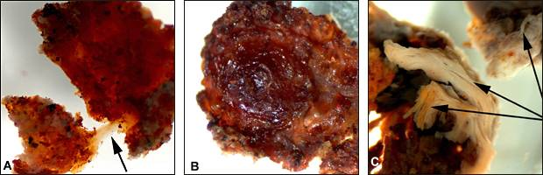
Science via AP
(From www.msnbc.msn.com/id/7285683/)
A: The arrow points to a tissue fragment that is still elastic. It beggars belief that elastic tissue like this could have lasted for 65 million years.
B: Another instance of “fresh appearance” which similarly makes it hard to believe in the “millions of years”.
C: Regions of bone showing where the fibrous structure is still present, compared to most fossil bones which lack this structure. But these bones are claimed to be 65 million years old, yet they manage to retain this structure.

One description of a portion of the tissue was that it is “flexible and resilient and when stretched returns to its original shape”.³
The exciting discovery was apparently made when researchers were forced to break open the leg bone of a Tyrannosaurus rex fossil to lift it by helicopter. The bone was still largely hollow and not filled up with minerals as is usual. Dr Schweitzer used chemicals to dissolve the bony matrix, revealing the soft tissue still present.⁴
She has been cited as saying that the blood vessels were flexible, and that in some instances, one could squeeze out their contents. Furthermore, she said, “The microstructures that look like cells are preserved in every way.” She also is reported as commenting that “preservation of this extent, where you still have this flexibility and transparency, has never been seen in a dinosaur before.”
It appears that this sort of thing has not been found before mainly because it was never looked for. Schweitzer was probably alert to the possibility because of her previous serendipitous discovery of T. rex blood cells. (It appears that the fossils were sent to her to look for soft tissues, prior to preservative being applied, because of her known interest.) In fact, Schweitzer has since found similar soft tissue in several other dinosaur specimens!
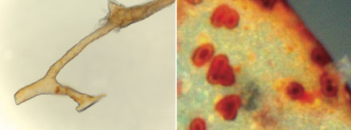
CREDIT: M. H. Schweitzer
Left: The flexible branching structures in the T. rex bone were justifiably identified as “blood vessels”. Soft tissues like blood vessels should not be there if the bones were 65 million years old.
Right: These microscopic structures were able to be squeezed out of some of the blood vessels, and can be seen to “look like cells” as the researchers said. So once again there is scope for Dr Schweitzer to ask the same question, “How could these cells last for 65 million years?”

The reason that this possibility has long been overlooked seems obvious: the overriding belief in “millions of years”. The long-age paradigm (dominant belief system) blinded researchers to the possibility, as it were. It is inconceivable that such things should be preserved for (in this case) “70 million years”.

Will they now be convinced?
Unfortunately, the long-age paradigm is so dominant that facts alone will not readily overturn it. As philosopher of science Thomas Kuhn pointed out,⁵ what generally happens when a discovery contradicts a paradigm is that the paradigm is not discarded but modified, usually by making secondary assumptions, to accommodate the new evidence.
That’s just what appears to have happened in this case. When Schweitzer first found what appeared to be blood cells in a T. Rex specimen, she said, “It was exactly like looking at a slice of modern bone. But, of course, I couldn’t believe it. I said to the lab technician: “The bones, after all, are 65 million years old. How could blood cells survive that long?’”⁶ Notice that her first reaction was to question the evidence, not the paradigm. That is in a way quite understandable and human, and is how science works in reality (though when creationists do that, it’s caricatured as non-scientific).
So will this new evidence cause anyone to stand up and say there’s something funny about the emperor’s clothes? Not likely. Instead, it will almost certainly become an “accepted” phenomenon that even “stretchy” soft tissues must be somehow capable of surviving for millions of years. (Because, after all, we “know” that this specimen is “70 million years old”.) See how it works?
Schweitzer’s mentor, the famous “Dinosaur Jack” Horner (upon whom Sam Neill’s lead character in the Jurassic Park movies was modeled) is already urging museums to consider cracking open some of the bones in their existing dinosaur fossils in the hope of finding more such “Squishosaurus” remains. He is excited about the potential to learn more about dinosaurs, of course. But—nothing about questioning the millions of years—sigh!
I invite the reader to step back and contemplate the obvious. This discovery gives immensely powerful support to the proposition that dinosaur fossils are not millions of years old at all, but were mostly fossilized under catastrophic conditions a few thousand years ago at most.⁷

References
- We have also reported on Identification of proteinaceous material in the bone of the dinosaur Iguanodon “dated” to 120 million years old (Connect Tissue Res. 2003; 44 Suppl 1:41–6). Return to text.
- Also at North Carolina State University. Return to text.
- Scientists recover T. rex soft tissue: 70-million-year-old fossil yields preserved blood vessels, www.msnbc.msn.com/id/7285683/, 24 March 2005. Return to text.
- Blood vessels recovered from T. rex bone, 24 March 2005, NewScientist.com news service. Return to text.
- Kuhn, T.S., The Structure of Scientific Revolutions, 3rd edition, University of Chicago Press, 1996. Return to text.
- Science 261:,/b>160, July 9, 1993. Return to text.
- Some dinosaur fossils could have formed in post-Flood local catastrophes. Return to text.

